Unitarian Universalist Community Church
Small Group Ministry Session
Symbols of Our Faith

Opening Words:
From the chalices, cups, and flagons of the world's ancient altars,
And from the flame named in the world's oldest scriptures --
A symbol of witness, sacrifice, and courage --
The Austrian artist Hans Deutsch created the Flaming Chalice
For the Unitarian Service Committee.
First used as a seal for papers and a badge for agents
Moving Europe's refugees to freedom during World War II,
The USC's Flaming Chalice became the living symbol
Of Unitarian Universalism throughout the world.
(See The Flaming Chalice, Dan Hotchkiss, http://www.uua.org/beliefs/chalice/151248.shtml)

Check-in: How is it with you today?

Topic/Activity:
When I joined the All Souls UU Church in Augusta in 1980, there were symbols of the flaming chalice surrounded by either one or two circles. The lighting of the chalice was becoming a ritual for worship at essentially all of our gatherings. I heard the history of the flaming chalice, but I was puzzled by the circles. The two circles were used to acknowledge the liberal Unitarian and Universalist traditions that came together organizationally in 1960, and the single circle symbolized the new combined faith tradition. I wondered: Were we two traditions or a merged tradition?

In the ensuing years, UUs have used the flaming chalice both with and without the circles, and have incorporated it into various designs, from the UU Service Committee logo, to the Young Religious UU, to the delightful symbol of a question mark. We may combine it with symbols of other traditions, such as the off-center chalice inspired by the older symbol of the off-centered cross. We add the colors of the rainbow for our LGBT work. Symbols come from and reflect our identity. Helen Zidowecki

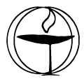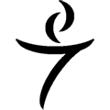
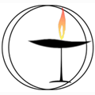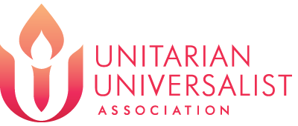

(For a great variety of symbols, see http://www.uua.org/communications/art/web/48720.shtml.)

- What symbols (of any idea or organization) have caught your attention over the years?

- Where and how do we use a symbol of UUism in our congregation?

- If you were to create a logo that represented Unitarian Universalism today, going into the future, what would it be?
Have materials: drawing paper, markers, clay or Play-Doh

- And now we come to the logo that was unveiled by the UUA in February 2014. Take a look at it – a long look. How does it reflect who we are today? Where is it going to take us?

Check-out: How was the session for you?

Closing Words:
When the fire of commitment sets our mind and soul ablaze
When our hunger and our passion meet to call us on our way
When we live with deep assurance of the flame that burns within
Then our promise finds fulfillment and our future can begin.
--Refrain from “From the Fire of Commitment” by Mary Katherine Morn and Jason Shelton, Singing the Journey, #1028

© Unitarian Universalist Community Church, Augusta, ME, 2014

