Small Group Ministry
Group Session Plan
The New Year: Endings and Beginnings

Opening Words:
The ceaseless flow of endless time no one can check or stay;
we’ll view the past with no regret, nor future with dismay.
The present slips into the past, and dream-like melts away;
the breaking of tomorrow’s dawn begins a new today.
The past and future ever meet in the eternal now;
to make each day a thing complete shall be our New Year vow.
“The Ceaseless Flow of Endless Time”, John Andrew Storey (Singing the Living Tradition #350)

Check in: How are you today?

Topic:
When does the New Year actually begin? Wikipedia gives a listing that shows that the New Year is celebrated somewhere in the world throughout the year.
*In 153 BCE the Romans moved observance of the New Year from late March to January 1, when newly elected senators assumed their positions to begin the New Year.

*In Vietnam and China, the lunar New Year celebration is between mid-January and mid-February.

*Other traditions celebrate the New Year in the Fall.
- The Jewish Rosh Hashanah marks the beginning of the agricultural autumn season and also a New Year. In ancient times, it marked the first day of the autumn season, a day of "memorial" or "blowing of the horn" (Leviticus 23:24-25, Numbers 29:1-6), but the New Year received little notice.
- In ancient Egypt, the New Year was celebrated when the Nile River flooded, which was near the end of September. Without the flooding of the Nile, people would not have been able to grow crops in the dry desert.
- Celts, who lived in what is now called France and parts of Britain before the Romans arrived, have Samhain, meaning 'summer's end', which is the basis for Halloween

*The Muslim calendar is based on the movements of the moon, so the date of the New Year is eleven days earlier each solar year.

Regardless of when the New Year is celebrated, the focus is on letting go of the past so there can be a rejuvenation for the new year.

In ancient Roman religion Janus is the god of beginnings and transitions, thence also of gates, doors, passages, endings and time. He is usually depicted as having two faces, since he looks to the future and to the past. The Romans named the month of January in his honor. Janus frequently symbolized change and transitions such as the progress of future to past, from one condition to another, from one vision to another, and from childhood to adulthood. | 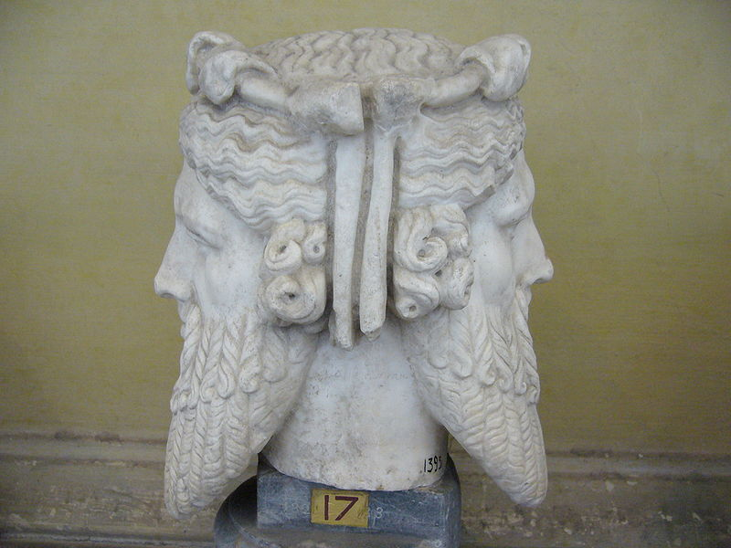

As we are beginning the New Year, share reflections on:
- What you are bringing forward into the New Year, and what you are leaving behind.
- What you are beginning in this New Year, and what you might be ending in the year.
- What obstacles you are facing this New Year and what you need to address them.

Likes and Wishes: How was this session for you?

Closing words: Excerpt from “Four Quartets” by T.S. Eliot
What we call the beginning is often the end
And to make an end is to make a beginning.
The end is where we start from. And every phrase
And sentence that is right . . . .
Every phrase and every sentence is an end and a beginning,

© Unitarian Universalist Community Church, Augusta, ME, January 2014

